**DAILY ONLINE ACTIVITIES SUMMARY**

|  |  |  |  |  |  |  |  |  |
| --- | --- | --- | --- | --- | --- | --- | --- | --- |
| **Date:** | **20-05-2020** | | | | | **Name:** | **Nachiketh S Bhat** | |
| **Sem & Sec** | **6th - B** | | | | | **USN:** | **4AL17CS119** | |
| **Online Test Summary** | | | | | | | | |
| **Subject** | | **SSCD** | | | | | | |
| **Max. Marks** | | **30** | | **Score** | | | **22** | |
| **Certification Course Summary** | | | | | | | | |
| **Course** | **Machine learning with python** | | | | | | | |
| **Certificate Provider** | | | **Cognitiviclass.ai (IBM)** | | **Duration** | | | **6 of 10** |
| **Coding Challenges** | | | | | | | | |
| **Problem Statement: one c-program, one-java and two python programs** | | | | | | | | |
| **Status: executed** | | | | | | | | |
| **Uploaded the report in Github** | | | | | **yes** | | | |
| **If yes Repository name** | | | | | <https://github.com/nachi0106/Daily-Activity/tree/master/Online-coding%20report/20-05-20> | | | |
| **Uploaded the report in slack** | | | | | **Yes** | | | |

Online Test Details:

First I A of SSCD

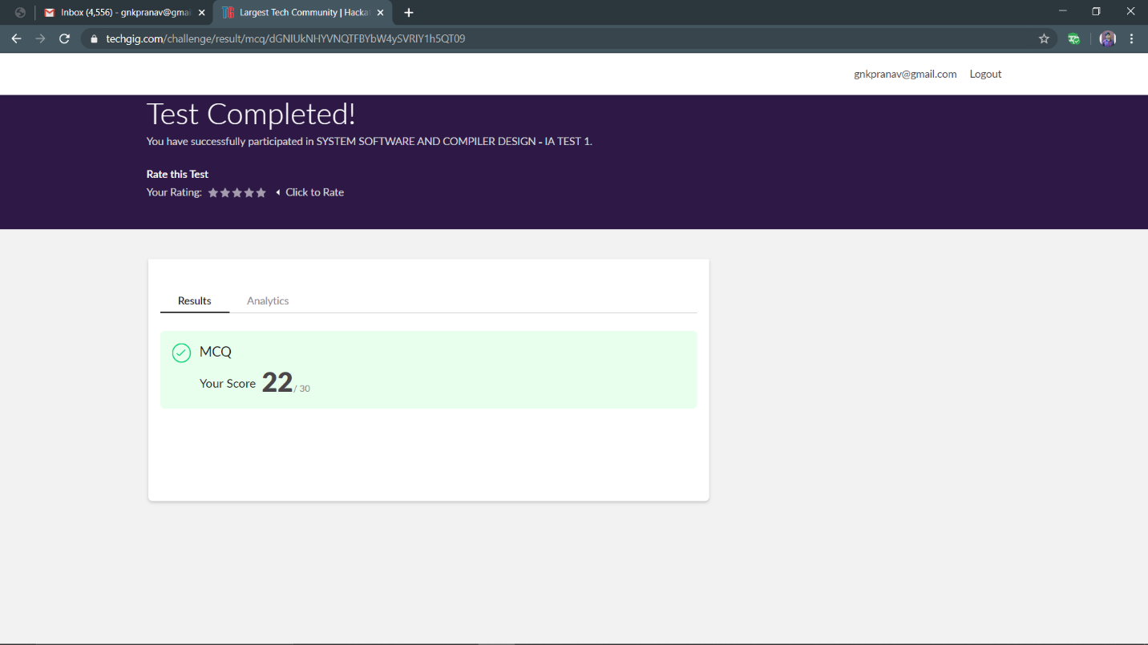

Certification Course Details:

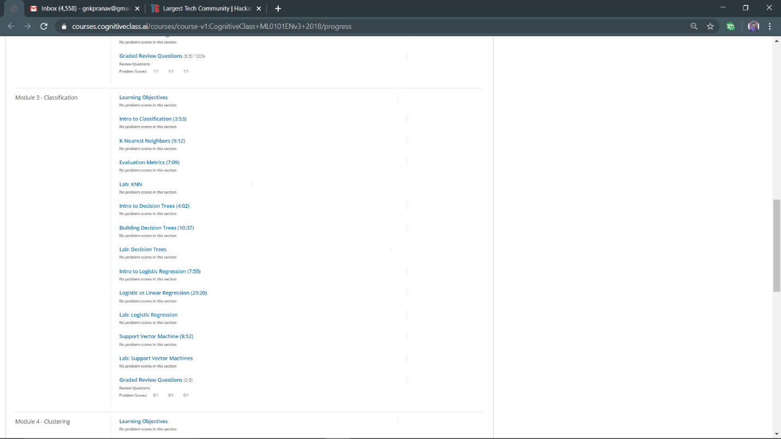

progress

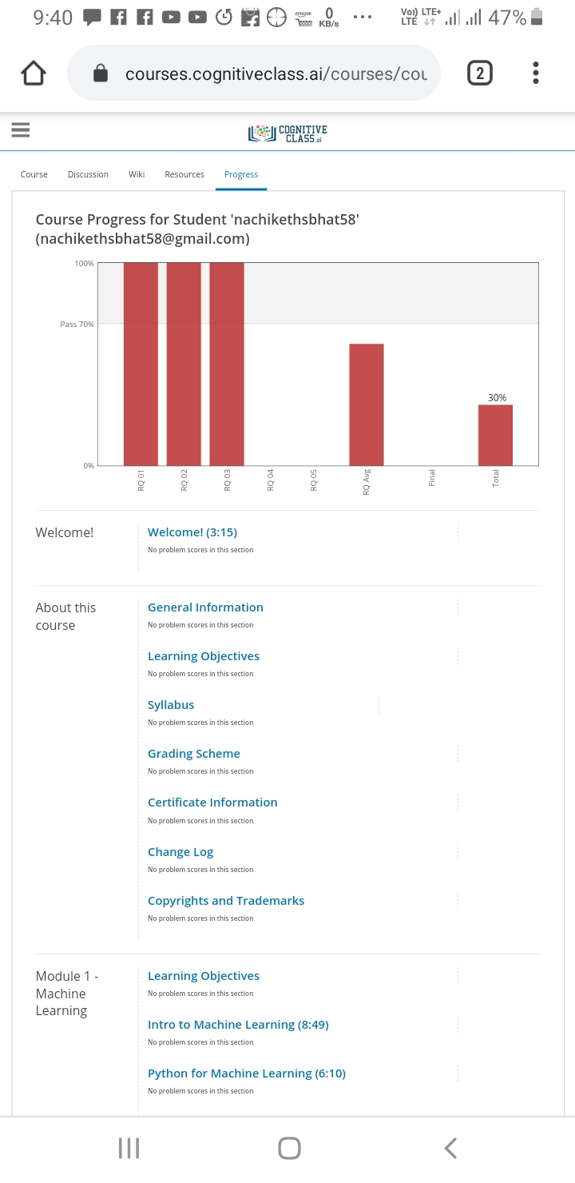

Coding Challenges Details

<https://github.com/nachi0106/Daily-Activity/tree/master/Online-coding%20report/20-05-20>

**1A**

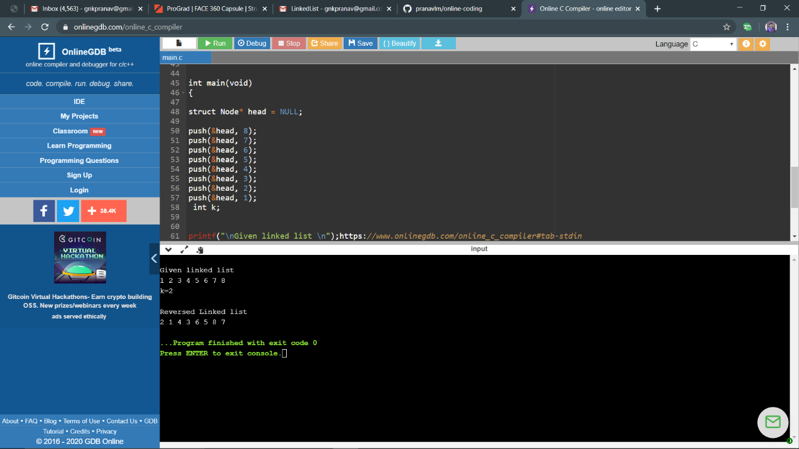

1B



2

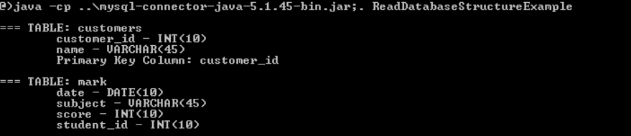

3

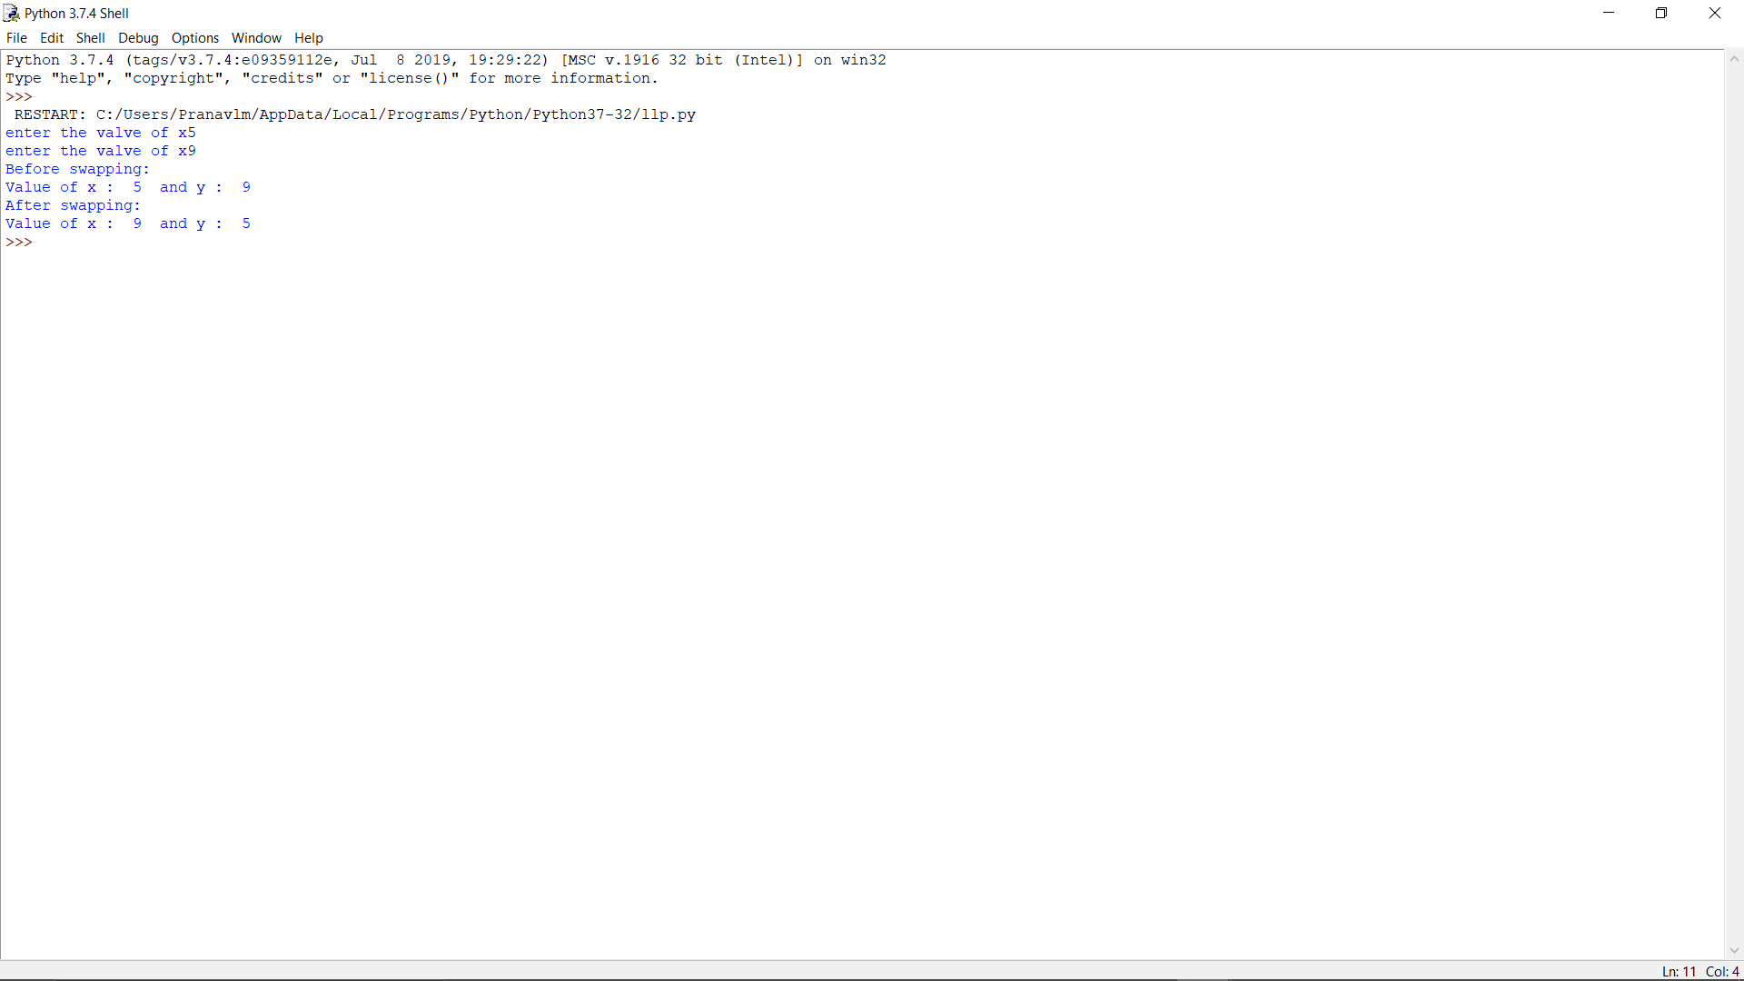

4

